|  |
| --- |
| govtofsindhlogo.jpgSTEVTA.jpg  **Employment through Skill**  PROSPECTUS 2018-19 |
| Accounts Group, Banking Group, Insurance Group, Salesmanship , Secretarial Group |
|  |

**Sindh Technical Education & Vocational Training Authority (STEVTA)**

**Government of Sindh**

**2-Year Diploma in Commerce (D. Com)**

**(Equivalent to inter-commerce)**

**Government Institutes of Business & Commercial Education (GIB&CE)**

                        



                        



            T 

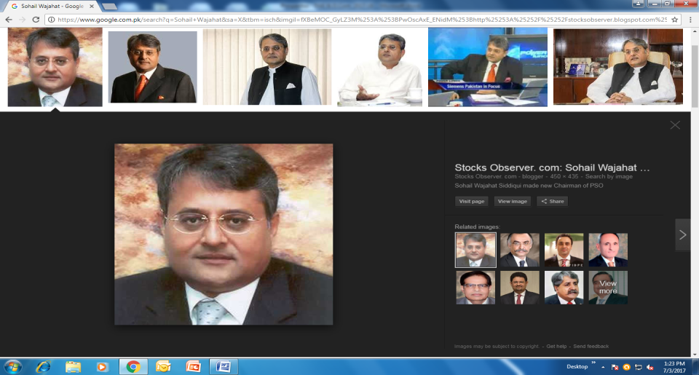

M

E

S

S

A

G

E

**Sohail Wajahat H. Siddiqui**

Member STEVTA Board of Governors

The rapid development in the technology and skill re-shaped the world of work while several new opportunities in the local and international labour market also opened for skilled workforce. Thus, the demand & scope of skilled labour force enhanced; moreover, Globalization has established competitive environment therefore, the major stakeholders of TVET sector are focusing the demand driven skill trainings for youth so that need of labour market be fulfilled.

We have to develop in our labour force quality skills, working-attitude, market awareness and target oriented approach that enable execution of quality job in first attempt because correction costs a lot and also precious time, which is actually “Money”.

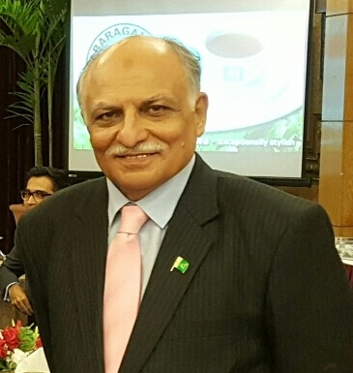

M

E

S

S

A

G

E

**Majyd Aziz Balgamwala**

President Employer Federation Of Pakistan

Member STEVTA Board of Governors

Majority of Developing Countries have taken Technical Education and Vocational Training (TVET) as a practical tool to address unemployment, especially of youth. In Pakistan, there is dependence on low skilled workers. In future un-skilled workers rarely get employment. It is therefore, imperative that industry-demand skills are developed to upgrade the skill, thus creating an enabling environment for the youth.

My message is simple for the youth. Take maximum advantage of the facilities, provided by the training institutions and endeavour to equip themselves with skills and technical knowledge. This is vital for their upward mobility and better financial benefits. Your future is, in your hand.

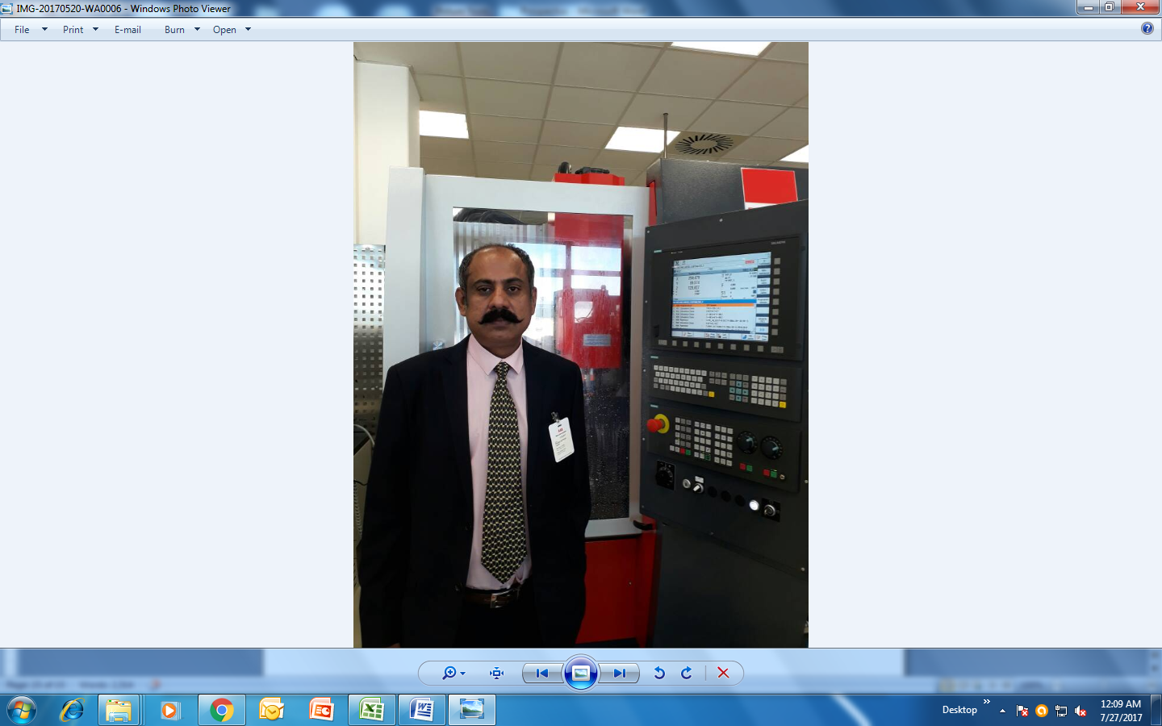

M

E

S

S

A

G

E

**Muzafar Ali Bhutto**

Managing Director

It is an admitted fact that the importance of Commercial Education cannot be ignored by giving less importance across the world. Since we have already entered into the era of global economic modernization. The study of theories and practice of commerce, trade business and industry enables a businessman to observe things in true colour. It equips him with the knowledge of the tendencies which work in the business market. The economic development of a Country is based on three fields i.e. Commerce, Industry and Agriculture. It is worth mentioning that all the Commercial Institutes of STEVTA are offering 2 year Diploma in Commerce (Equivalent to Inter Commerce) in the groups viz; Accounts, Banking, Insurance, Salesmanship and Office Secretarial Practice. I am sure these groups of D.Com will be most beneficial and helpful to produce a force of Administrators, Managers, Accountants, Secretaries, Stenographers, Cashiers, Office / Accounts Assistants, Sales Representatives and skilled Computer Operators etc to meet the requirement locally and internationally.

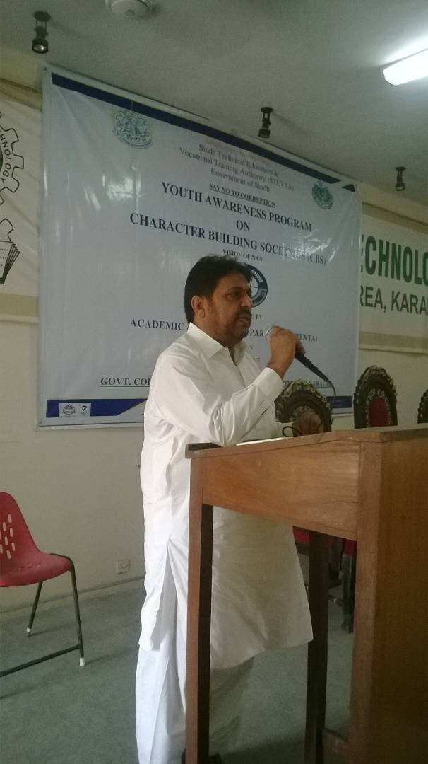

M

E

S

S

A

G

E

**Engr Liaquat Ali Jamro**

Director (Academics & Training)

This is matter of great pleasure for me to apprise that Sindh TEVTA has focussed on training delivery and professional look of Institutes and thus uplifting its existing infrastructure for the demand driven skill training. Academia is also being encompassed in the different capacity building program so that the Industry matched latest training methods shall be applied and the Youth of sindh be equipped with latest skill set so that these skill work-force could be accommodate in the local as well as international Labour Market for social economic development. I am much confident on my all team at HQ level, Regional Level specially Principals who are working very hard for the betterment of Institutions and academia however; their keen efforts made the Institution, a learning environment where you can flourish your professional career.

|  |  |  |
| --- | --- | --- |
| **S.No** | **CONTENTS** | **Pg No** |
| **01** | **INTRODUCTION OF SINDH TEVTA** | **07** |
| **02** | **IMPORTANCE OF COMMERCIAL EDUCATION** | **08** |
| **03** | **DIPLOMA IN COMMERCE** | **09** |
| **04** | **STUDENT AFFAIRS** | **10** |
| **05** | **BOOKS AND INSTRUMENTS** | **09** |
| **06** | **ADMISSION POLICY** | **10-13** |
| **07** | **ADMISSION SCHEDULE** | **13** |
| **08** | **FEE STRUCTURE** | **14** |
| **09** | **LIST OF REGION-WISE INSTITUTES& COURSES OFFERED** | **15-18** |
| **10** | **GENERAL INSTRUCTIONS FOR CANDIDATES** | **19** |
| **11** | **ACADEMIC CALENDAR SESSION 2018-19** | **20** |
| **12** | **EQUIVALENCY CERTIFICATE (D.COM)** | **21** |
| **13** | **SCHEME OF STUDIES** | **22** |
| **14** | **FUTURE PROGRAMS** | **23** |

**INTRODUCTION SINDH TEVTA**

Sindh Technical Education and Vocational Training Authority (SindhTEVTA) was established through the SindhTEVTA Ordinance, 2007 (Ordinance XVII of 2007) to streamline the Technical Education and Vocational Training in the province.

Accordingly, the administrative control of all TVET Institutions has been transferred to SindhTEVTA and thereafter, the Sindh Assembly passed the SindhTEVTA Bill 2009 on March 29, 2010, which was accented by the Governor of Sindh as the STEVTA Act, 2009.

In order to extend complete autonomy for re-organization and effective management, the policy making task has been entrusted to the SindhTEVTA Board of Governors (BoG). The BoGs comprises the eminent professionals from Public & Private Sector, Employer Federation of Pakistan (EFP),Chamber of Commerce & Industries (CCIs), Agriculturist and the Sindh Government senior Officers.

**1.2 VISION:** Skill for employability and sustainable socio-economic development.

**1.3 MISSION:** Provide demand driven skilled training/ professional courses to produce the workforce/ professionals for local and international market.

**1.4 OBJECTIVES:**

To manage and regulate the technical education and vocational training in close co-ordination with industry/ market in the Province and for matters connected there with and ancillary there to

**2.1 IMPORTANCE OF COMMERCIAL EDUCATION:**

The importance of Commercial Education all over the world cannot be ignored, as we have entered into an era of global economic modernization and for real progress of commerce and industry, we need adequate efficient and fully trained office, economics and business managers. The study of marketing, accountancy, finance, and office management are the disciplines being taught/ introduced in commercial education. Therefore, commercial education is equally important for the youth of our country/province for socio economic development and sustainability. The prime objective of commercial education is to provide our youth both with the theoretical and practical aspects of all matters relating to commerce and business administration and office management as per requirement. It also covers professional courses like costing, budgeting, marketing, income tax practice and opportunities to the future professionals to acquire higher studies as well.

**2.2 THE SCOPE OF DIPLOMA IN COMMERCE (D.COM):**

The economic development mechanism of a country is based upon three fields, i.e. commerce, industry and agriculture. The complete success in these fields can be achieved with the help of efficient, educated and properly trained Business / Office managers. The field of business / office management and commerce requires the services of administrators, managers, accountants, secretaries, Junior Executives, and sales managers/ Executives. There is a dearth of these qualified and trained professionals in our society / corporate sector. Diploma in Commerce (D. Com) is equivalent to Intermediate (Commerce), which will fill-in the gap/shortage presently the relevant sector is experiencing by producing the future professionals by selecting this educational line .

* 1. **OPTIONAL GROUPS OF D.COM**

The candidate may opt any one of the following Groups.

1. **Accounts 2. Banking 3. Insurance 4. Salesmanship 5. Office Secretarial Practice**

Keeping in view the demand, the Diploma in Commerce has been introduced in 40Government institutes of Business and Commercial Education in Sindh.

**3.0 STUDENTS/ FUTURE PROFESSIONALS AFFAIRS**

**3.1 DISCIPLINES**

Future professional Students require to maintain proper discipline in the institutions and any breach of discipline will render the future professional liable to expulsion after due course of procedure. The Principal of the Institute / Disciplinary Committee as the case maybe shall be the final authority in the matters pertaining to disciplinary action / expulsion, imposition of special fines.

**3.2 RULES AND REGULATIONS**

Future Professional are required to abide-by rules and regulations enforced. The timetable as well as academic Programme of the institute can be altered as per requirement/need without assigning any reason at anytime keeping in view the exigencies.

**3.3 LEAVE RULES**

Prior permission / sanction for Leave shall be required to obtain from the concerned Head of Institute/Head of Department except in cases of emergency, such as, sickness etc. subject to produce medical certificate by concerned future from a registered medical practitioner. Leave, even if granted, shall not be exempted from any test, examination or other specifically assigned task, workshop assignment or fulfilment of mandatory attendance requirement of the Certificate awarding Body / Board.

**3.4 ATTENDANCE RULES**

The Students / future professionals shall be liable to maintain regular attendance/ checks. The Head of Institute will submit weekly attendance report to the Regional Director, Sindh TEVTA. Admission of the future professionals, having less than 75% attendance shall make the future professional liable to be terminated/ not to allow enter into examination as per the SBTE’s attendance promotion rule.

**3.5 BOOKS AND INSTRUMENTS**

Every Student / Future Professional shall be required to purchase necessary books and instruments at his / her own expenses. The list of books shall be obtained from the concerned subject faculty. Reference books and lending facility would be available in library of the respective Institutes.

**3.6 UNIFORM CODE**

Students / Future Professional are required to wear the prescribed uniform/ dress code.

**3.7 REFUND OF SECURITY DEPOSIT**

Application for refund of security deposit along-with clearance certificate maybe submitted within one year from the date the Student / future professional discontinues/ pass outs his / her education. The claim shall not be entertained if not applied within the prescribed/ permissible limit/ date.

**4.1 FULL / HALF FREE-SHIP (MORNING SHIFT REGULAR PROGRAMME ONLY)**

Fee concession of full and half Free-ship in Tuition fee will be available for upto 10% of total enrolment for the deserving / meritorious students/ future professionals according to the existing government rules.

1. **ADMISSION POLICY / PROCEDURE**

Admission shall be offered on merit / quota / allocation basis at respective Government Institute of Business Commercial Education (GIB&CE) in Sindh.

**5.1 ELIGIBILITY**

Secondary School Certificate (SSC) / Technical School Certificate(TSC)/ Matric Tech **or** Equivalent or Intermediate

Age: Minimum 15 Years, Maximum 28 Years

**5.2 Merit order**

Admission is granted as per seats allocation according to merit determined by the Institute Admission Committee on the basis of Percentage of Marks obtained in Secondary School Certificate (SSC) / Matric or equivalent. In case of tie, the candidate older in age shall be given preference.

**5.3 POWERS FOR UPPER AGE RELAXATION**

|  |  |  |
| --- | --- | --- |
| **Age relaxation up to** | **Programme** | **Responsibility** |
| Up-to 2-year | Morning Programme (MP) | Head of respective Institute |
| Upto 2-5 year | Morning Programme (MP)  Double Shift Program | Regional Director, STEVTA |

**NB:** Overage candidates should submit Age Relaxation Certificate at the time of submission of Admission Form.

**5.4 INELIGIBILITY**

* Less than 33% marks in SSC (Science)/Matric or Equivalent
* Failed in any Subject of SSC / Matric or Equivalent
* Not within the Age brackets as specified above.
* ***In case of Over-age candidate*,** Failure to submit Age Relaxation Certificate with Admission Form.

**5.5 DIS-QUALIFICATION**

* Any form without the attachment of deposit voucher**.**
* Any attempt to exert influence / intimidate directly or indirectly for getting Admission.
* In case of any entry found incomplete or illegible in the Admission Form.
* Any alteration or manipulation in the Admission Form / Documents.
* Parallel admission in any other educational institutions or Boards, in the same shift of program.

**NB:** To promote equity &provide access to the girls are allowed to take admissions in the institutes as per merit / policy

|  |  |  |  |  |
| --- | --- | --- | --- | --- |
| **S#** | **Category** | **Percentage Distribution** | | **Distribution of 50 Seats** |
| **Percentage** | **Detailed Breakup** |
| 1 | Open Merit (Distribution of Admission) | 60% | 1. Technical School Certificate (TSC)/Matric Tech/Secondary School Certificate (SSC)/Matric Science | 24 |
| 1. Higher School Certificate (HSC)/Intermediate (Pre Engineering) | 06 |
| 2 | All Sindh Basis  (Excluding District Of Admission) | 30% | i) Technical School Certificate (TSC)Secondary School Certificate (SSC) | 12 |
| ii) Higher School Certificate (HSC)/Intermediate (Pre Engineering) | 03 |
| 3 | Reserved Seats | 10% | **for distribution of seats please see 5.7** | 05 |

**5.6 ALLOCATION OF SEATS**

**5.7 DISTRIBUTION OF 10% RESERVED SEATS (ALL OVER SINDH BASIS)**

|  |  |  |  |
| --- | --- | --- | --- |
| **S#** | **PERCENTAGE** | **CATEGORY /GROUP** | **NUMBER OF SEATS** |
| **A** | **5%** | Children of Defence personnel | 1. Army = 30 Seats ii) Navy = 10 Seats iii) Airforce = 10 Seats |
| Reserved Seats | 1. Makran Zone (Baluchistan) = 50 Seats 2. Azad Kashmir = 02 Seats iii) Fata = 02 Seats   iv) Northern Area = 01 Seats |
| Candidates with Disability | 1% of the total seats 5% of reserved seats |
| **B** | **3%** | Real Sons/Daughters/Sisters/Brothers of the  Employees of Sindh TEVTA Employee of Sindh TEVTA and Sindh Board of Technical Education | 3% of the total seats |
| **C** | **2%** | Khawaja Sara / She-Male | 2% of the total seats |

**6. 0 ADMISSION PROCESS**

**6.1 PURCHASE & SUBMISSION OF ADMISSION FORMS**

Candidate/Future Professional shall obtain the admission package(prospectus, admission Form, Fee Deposit Slip) from any institute on cash payment of Rs.200/-. The Application Form dully filled shall be submitted to the respective institutes.

**6.2 Document SCRUTINY & Verification BY INSTITUTES**

The Provisional Selection of candidates/ Future Professionals will be subject to verification of Documents from the respective Boards of Education or Certificate issuing authority candidate. However, Rs. 100/- will be paid by the candidate/ future professional at the time of admission for Document Scrutiny fee / services provided by Institute.

**7.0 ADMISSION SCHEDULE**

|  |  |
| --- | --- |
| **Activities** | **Schedule (2018-2019)** |
| Open House Activities shall start from | AUGUST 13, 2018 |
| Last date for submission of Admission Forms | SEPTEMBER 29, 2018 |
| Merit List to be Displayed | OCTOBER 04, 2018 |
| Last date for Fee Deposit | OCTOBER 06, 2018 |
| Commencement of Classes | OCTOBER 10, 2018 |

**8.0 TIMING OF THE CLASSES**

|  |  |  |  |  |
| --- | --- | --- | --- | --- |
| **Working Days** | **Contact Hour**  (Period Duration) | **Number of Periods** | **Morning Timing** | **Evening Time** |
| Weekdays  (Mon ~ Sat except Friday) | 45 Minutes | 07 | 8:30 AM - 1:45 PM | 2:00 PM - 7:15 PM |
| Friday | 06 | 8:30 AM - 1:00 PM | 2:30 PM - 7:00 PM |

**9.0 FEE STRUCTURE**

|  |  |  |  |  |  |
| --- | --- | --- | --- | --- | --- |
| **S. #** | **Fee Heads / Sub Heads** | **MP (Mor.)** | | **DSP (EVE.)** | |
| **1st Year** | **2nd Year** | **1st Year** | **2nd Year** |
| 1 | Admission Fee | 50 | -- | 50 | -- |
| 2 | Tuition Fee | 200 | 200 | 200 | 200 |
| 3 | Computerised Identity Card fee | 50 | 50 | 50 | 50 |
| 4 | Security Deposit (Refundable) | 100 | -- | 100 | -- |
| 5 | Institute Development Fund | 200 | 200 | 200 | 200 |
| 6 | Sports Fund | 50 | 50 | 50 | 50 |
| 7 | Computer Lab Fund | 100 | 100 | 100 | 100 |
| 8 | Institute Management Committee Funds (ex PTA Funds) | 100 | 100 | 100 | 100 |
| 9 | Utilities Service Charges | 50 | 50 | 50 | 50 |
| 10 | Library Fund | 50 | 50 | 50 | 50 |
| 11 | Institute Affiliation / Registration Fee | 100 | -- | 100 | -- |
| 12 | Medical Fund (First Aid) | 50 | 50 | 50 | 50 |
| **Total Fee/ Fund** | | **1100** | **850** | **1100** | **850** |

**NB**:

1. Fee & Funds will only be deposited through Pay Order into the respective GIB&CE Bank Account.
2. All Fees/Funds are payable to the institution before the commencement of Academic Year.
3. Other Charges as follows:
4. Duplicate Identity Card Rs. 50**/-**
5. Provisional Certificate Rs. 100**/-**
6. Appearance Certificate Rs. 100**/-**
7. Other certificates (Bonafide / Character) Rs. 100**/-**

SBTE Student Registration&ExaminationFee (As prescribed by the SBTE)

**10.0 List of REGION-WISE Institutes/ COURSES OFFERED**

|  |  |  |  |  |  |  |  |  |  |
| --- | --- | --- | --- | --- | --- | --- | --- | --- | --- |
| **Karachi Region** | | | | | | | | | |
| **#** | **District** | **Name Of Institution** | | **Contact No.** | | **No. Of Seats** | | | |
| **MP (Mor.)** | | **DSP (EVE.)** | |
| 1 | Gulberg Town | GIB&CE, Azizabad | | 021-36377246 | | 150 | | 200 | |
| 2 | Gulshan Town | GIB&CE, Gulistan-e-Jauhar | | 0300-0365517 0331-2499941 | | 100 | | -- | |
| 3 | Lyari Town | GIB&CE, Lyari | | 0321-2826215 | | 100 | | -- | |
| 4 | Malir Town | GIB&CE, Malir | | 0334-0302008 | | 100 | | -- | |
| 5 | Orangi Town | GIB&CE, Sector 111/2, Orangi Town | | 0301-2251733 | | 50 | | -- | |
| **TOTAL** | | | |  | | **500** | | **200** | |
| **Hyderabad Region** | | | | | | | | | |
| **#** | **District** | | **Name Of Institution** | | **Contact No.** | | **No. Of Seats** | | |
| **MP (Mor.)** | | **DSP (EVE.)** |
| 1 | Badin | | GIB&CE, Badin | | 0347-2640252 | | 50 | | -- |
| 2 | Dadu | | GIB&CE, Dadu | | 0259-200225 | | 50 | | -- |
| 3 | GIB&CE, Mehar | | 0300-2980086 | | 50 | | -- |
| 4 | Hyderabad | | GIB&CE, Latifabad | | 0333-2983272 0313-3037967 | | 100 | | -- |
| 5 | GIB&CE, Qasimabad | |  | | 50 | | 50 |
| 6 | Jamshoro | | GIB&CE, Sehwan Sharif | | 0301-3490124 | | 50 | | -- |
| 7 | Matiari | | GIB&CE, Hala | | 0300-3044551 | | 50 | | -- |
| 8 | Tando Allahyar | | GIB&CE, Tando Allahyar | | 022-0389295 | | 50 | | -- |
| 9 | Thatta | | GIB&CE, Thatta | | 0302-2849870 | | 50 | | -- |
| 10 | GIB&CE, Gharo | | 0336-2771019 | | 50 | | -- |
| 11 | Sujawal | | GIB&CE, Sujawal | | 0336-3008706 | | 50 | | -- |
|  | | | **TOTAL** | |  | | **600** | | **50** |

|  |  |  |  |  |  |
| --- | --- | --- | --- | --- | --- |
| **Mirpurkhas Region** | | | | | |
| **#** | **District** | **Name Of Institutions** | **Contact No.** | **No. Of Seats** | |
| **MP (Mor.)** | **DSP (EVE.)** |
| 1 | Mirpurkhas | GIB&CE, Digri | 0332-3325909 0307-3435578 | 50 | -- |
| 2 | GIB&CE, Mirpurkhas | 0334-2029651 | 50 | -- |
| 3 | Tharparkar | GIB&CE, Mithi | 0345-3898776 | 50 | -- |
| 4 | Umerkot | GIB&CE, Umerkot | -- | 50 | -- |
| **TOTAL** | | |  | **200** | **-** |

|  |  |  |  |  |  |  |  |
| --- | --- | --- | --- | --- | --- | --- | --- |
| **Sukkur Region** | | | | | | | |
| **#** | **District** | **Name Of Institution** | |  | | **No. Of Seats** | |
| **MP (Mor.)** | **DSP (EVE.)** |
| 1 | Ghotki | GIB&CE, Ghotki | | 0301-3828339 | | 50 | -- |
| 2 | Khairpur | GIB&CE, Khairpur | | 0333-7597343 | | 50 | -- |
| 3 | GIB&CE, Pir-Jo-Goth | | 0332-2737408 | | 50 | -- |
| 4 |  | GIB&CE, ThariMirwah | | 0300-3145389 | | 50 | -- |
| 5 | Sukkur | GIB&CE, Rohri | | 0333-7226083 | | 50 | -- |
| 6 | GIB&CE, Sukkur | | 0333-7171254 | | 50 | -- |
| **TOTAL** | | |  | | **300** | | **-** |

|  |  |  |  |  |  |
| --- | --- | --- | --- | --- | --- |
| **Shaheed Benazirabad Region** | | | | | |
| **#** | **District** | **Name Of Institutions** | **Contact List** | **No. Of Seats** | |
| **MP (Mor.)** | **DSP (EVE.)** |
| 1 | Benazirabad | GIB&CE, Kazi Ahmed | 0333-7540881 | 50 | -- |
| 2 | GIB&CE, NawabShah | 0333-7062803 | 50 | -- |
| 3 | Naushahro Feroz | GIB&CE, Kandiaro | 0300-3376894 | 50 | -- |
| 4 | GIB&CE, Naushahro Feroz | 0301-3896056 | 50 | -- |
| 5 | Sanghar | GIB&CE, Khipro | 0366-2572815 | 50 | -- |
| 6 | GIB&CE, Sanghar | 0345-3730984 | 50 | -- |
| 7 | GIB&CE, Tando Adam | 0301-3850068 | 50 | -- |
| **TOTAL** | | |  | **350** |  |

|  |  |
| --- | --- |
|  |  |

|  |  |  |  |  |  |
| --- | --- | --- | --- | --- | --- |
| **Larkana Region** | | | | | |
| **#** | **District** | **Name Of Institutions** | **Contact No.** | **No. Of Seats** | | |
| **MP (Mor.)** | **DSP (EVE.)** | |
| 1 | Jacobabad | GIB&CE, Jacobabad | 0333-2872989 | 50 | -- | |
| 2 | KambarShahdadkot | GIB&CE, Mirokhan | 0346-3371145 | 50 | -- | |
| 3 | GIB&CE, Shahdadkot | 0334-2065401 | 50 | -- | |
| 4 | Kashmore | GIB&CE, Kandhkot | -- | 50 | -- | |
| 5 | Larkana | GIB&CE, Larkana | 0333-7540881 | 50 | -- | |
| 6 | Shikarpur | GIB&CE, Lakhi | 0332-2764192 | 50 | -- | |
| 7 | GIB&CE, Shikarpur | 0306-3411782 | 50 | -- | |
| **TOTAL** | | |  | **350** | **-** | |

**GIB&CE: Government Institute of Business & Commercial Education**

|  |
| --- |
| **General instructionS FOR A candidate/ FUTURE PROFESSIONAL**   1. Please fill in the Admission Formneatly and carefully in your own handwriting. 2. Please fill in your “category” as per status of Domicile / P. R. C. 3. Please attach undertakings/ AFFIDAVIT (given in Admission Form) on the Stamp Paper costing Rs. 50/-. 4. Photocopy of Admission Form is not acceptable. 5. Attach the attested copies of all the following Documents / Certificates (in duplicate);: 6. College Leaving Certificate, if applicable. 7. Matriculation Certificate showing the date of birth (Original / Provisional). 8. Marks Sheet of HSC/ Matriculation (Technical / Science) Examination or equivalent from the relevant Board. 9. Six recent photographs duly attested. 10. Domicile Certificate of the Applicant / Father’s (including Candidate’s Name) and Permanent Residence Certificate. 11. Hafiz-e-Quran Certificate, if applicable. 12. Migration Certificate (if applicable). |

**CPEC INTERVETNTION**

**STEVTA LAUNCHES CHINESE LANGUAGE WITH ITS BLENDED PROGRAM**

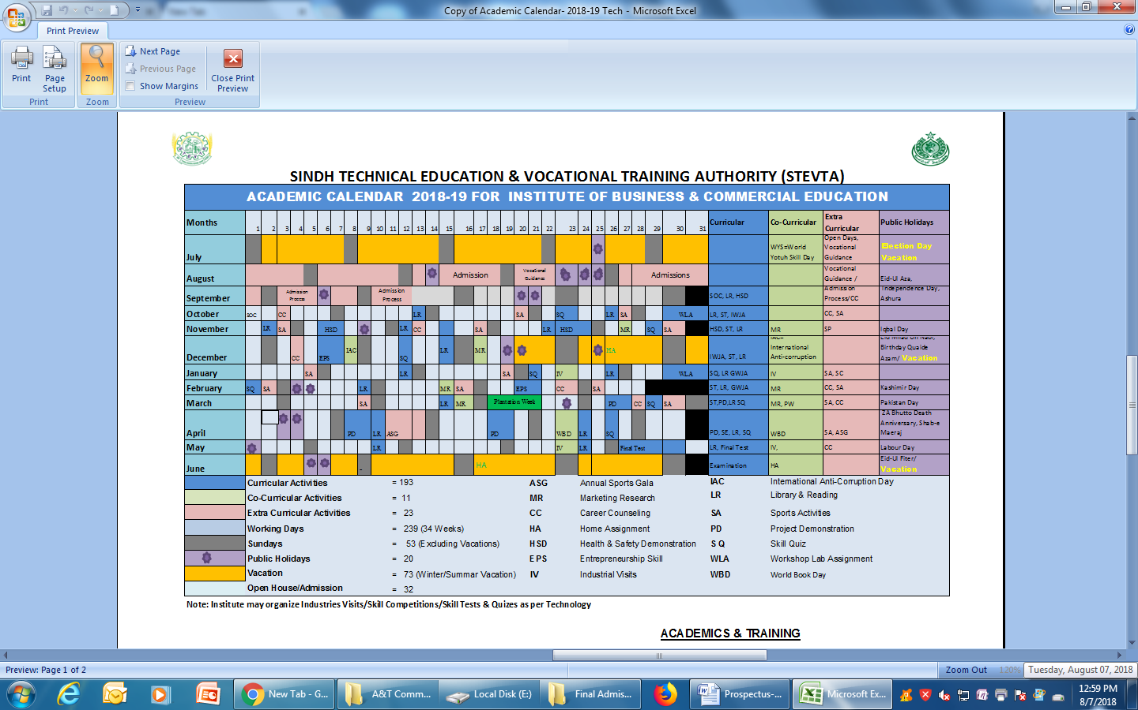



**SCHEME OF STUDIES 2-YEAR DIPLOMA IN COMMERCE (D.COM) PART I & II  
 APPROVED BY THE SINDH BOARD OF TECHNICAL EDUCATION**

|  |  |  |  |  |
| --- | --- | --- | --- | --- |
| 1 | Accounts Group | Compulsory Subjects for all groups | English, Urdu, Sindhi, Islamic Studies | English, Urdu, Sindhi, Pakistan Studies |
| Supporting Subjects | Business IT-I | Business IT-II |
| Principal of Banking | Principal of Economics |
| Principal of Commerce | Principal of Communication |
| Specialization | Financial Accounting-I | Financial Accounting-II |
| Business Maths& Statistic | Applied Accounting |
|  | Manual / Computerized based |
| 2 | Secretarial Group | Supporting Subjects | Business IT/English/Urdu Typing | Business IT-II/, |
| Financial Accounting-I | Business IT-I |
| Principal of Commerce | Principal of Commerce  Communication Skills |
| Specialization | English / Urdu Shorthand-I | English / Urdu Shorthand-II |
| Computerized based Correspondence |
| 3 | Banking Insurance & Salesmanship | Supporting Subjects | Business IT-I | Business IT-II/ |
| Financial Accounting-I | Principal of Economics |
| Principal of Commerce | Communication Skills |
| Specialization for Banking | Principal of Banking | Financial Accounting-II |
| Currency & Finance | E.Banking |
| Supporting for Insurance | Risk Insurance | Business Environment |
| Insurance Practice | Insurance Practice-II |
| Specialization for Salesmanship | Principal of Salesmanship | Entrepreneurship Advertisement |
| Principal of Marketing |

**Offered PROGRAMS**

**2-Year**

Diploma in Commerce (D.Com) with Special Groups: Accounts /Insurance / Salesmanship / Banking / Secretarial Practices

**1-Year**

a)   Diploma in Computer & Business Management (DCBM)*

b)   Diploma in Business Administration (DBA)*

c)    Chinese Language Program *

d)    Occupational Health & Safety (OHS) Diploma Program*

e) Diploma in Information Technology (DIT)

 f) Stenography /Shorthand & Typing